**Ledoux criterion**

* For gaseous, non-rotating single stars, without strong magnetic fields, the only forces acting on a mass element are from pressure and gravity, which results in a spherically symmetrical configuration.
* Density then becomes $ρ=ρ(r, t)$ where r and t are independent variables
* As the star (masses of 15 and 20 Mʘ) evolves on the MS, a gradient of chemical composition develops at the outer border of the convective core. If the Schwarzschild criterion context is used (convective instability if $∇_{rad} ≥∇_{ad}$), then the outwards increase of opacity leads to the formation of a region of semiconductive instability outside the convective core
* Therefore a mixing of matter occurs until the neutrality of gradients is reached ($∇_{rad}= ∇_{ad}$).
* During the post MS this region becomes an intermediate convective zone which develops as H begins burning in a shell in the μ-gradient region.
* If the Ledoux criterion is used instead (convective instability if $∇_{rad} ≥ ∇_{ad}+\frac{Β}{4-3Β}∇μ, where Β is the ratio of the gas to the total pressure)$ then the role of μ-gradients on the stability against convection is considered
* Adopting this criterion does not change the size of the convective core during the MS phase, however a convective region located outside the convective core appears during the MS phase at the base of the homogeneous region at $\frac{m}{M}=0.45$ in the 20Mʘ model and $\frac{m}{M}=0.39$ in the 15Mʘ model.
* 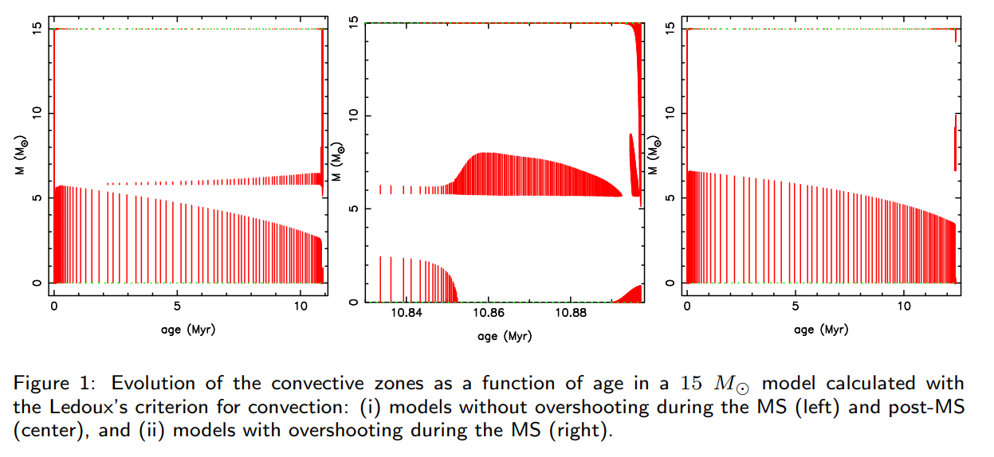
* Central panel shows the convective region which results from the outwards increase of opacity in a region where $∇μ=0$, hence the Schwarzschild and Ledoux criterion are equivalent.
* The location of the intermediate convective zone (ICZ) corresponds to that of the maximum extension of the convective core during the MS-phase, and it remains the same during the post MS-phase until the onset of He-burning.
* The location and size of the ICZ during the post MS-phase in models adopting the Ledoux criterion are different from models adopting the Schwarzschild criterion.
* With Ledoux’s criterion, the thickness of the ICZ can reach 15-20% of the star’s total mass, however when overshooting is included ($∇=∇_{ad} in the overshoot region$), no ICZ appears during the MS for M=15ʘ and appears later for M=20ʘ than in models without overshooting
* 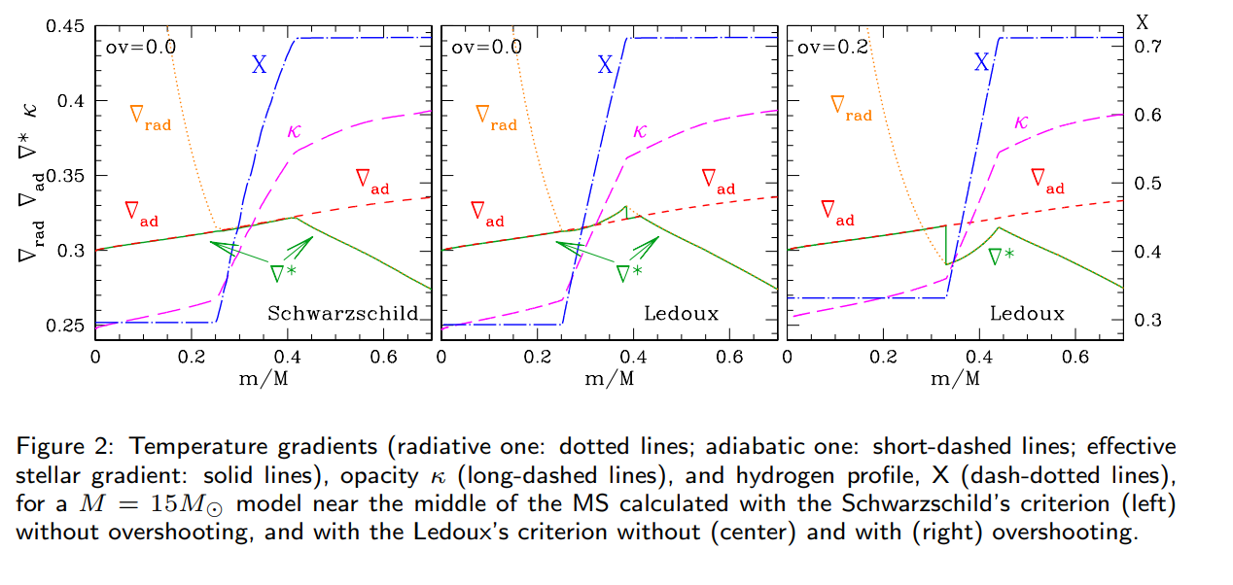
* In models computed with the Ledoux’s criterion, the μ-gradient region located below the ICZ brings a large contribution to the Brunt–Väisälä frequency NBV which leads to a strong damping of the models
* In models computed with the Schwarzschild criterion, the ICZ, which is closely related to the H-burning shell, is located within the μ-gradient region.
* In the ICZ, NBV = 0, which corresponds to less radiative damping.
* In models computed with the Ledoux’s criterion , the ICZ is thin and located at higher values of m/M, at the base of the homogeneous region therefore NBV remains high in the μ-gradient region which leads to more radiative damping.
* This means more models are excited when computed with the Schwarzschild criterion than those computed with the Ledoux’s criterion.

Lebreton, Y., Montalbán, J., Godart, M., Morel, P., Noels, A. and Dupret, M.A., 2009. Ledoux's convection criterion in evolution and asteroseismology of massive stars. *arXiv preprint arXiv:0907.1448*.